Pic 1: Empty Activity

Then I went to xml file of my first activity, there I added text file view to the application and I added a button view with id Button and text Button too.

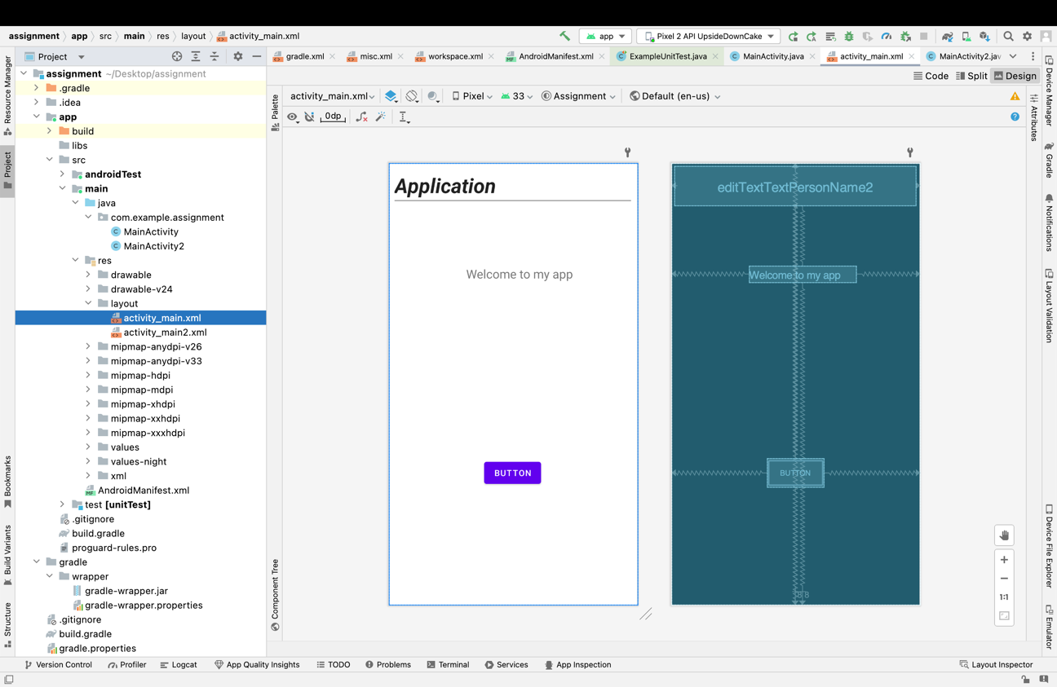

Pic 2: first activity

Then I created 2nd activity named as MainActivity2. After that I added a text view there as well.

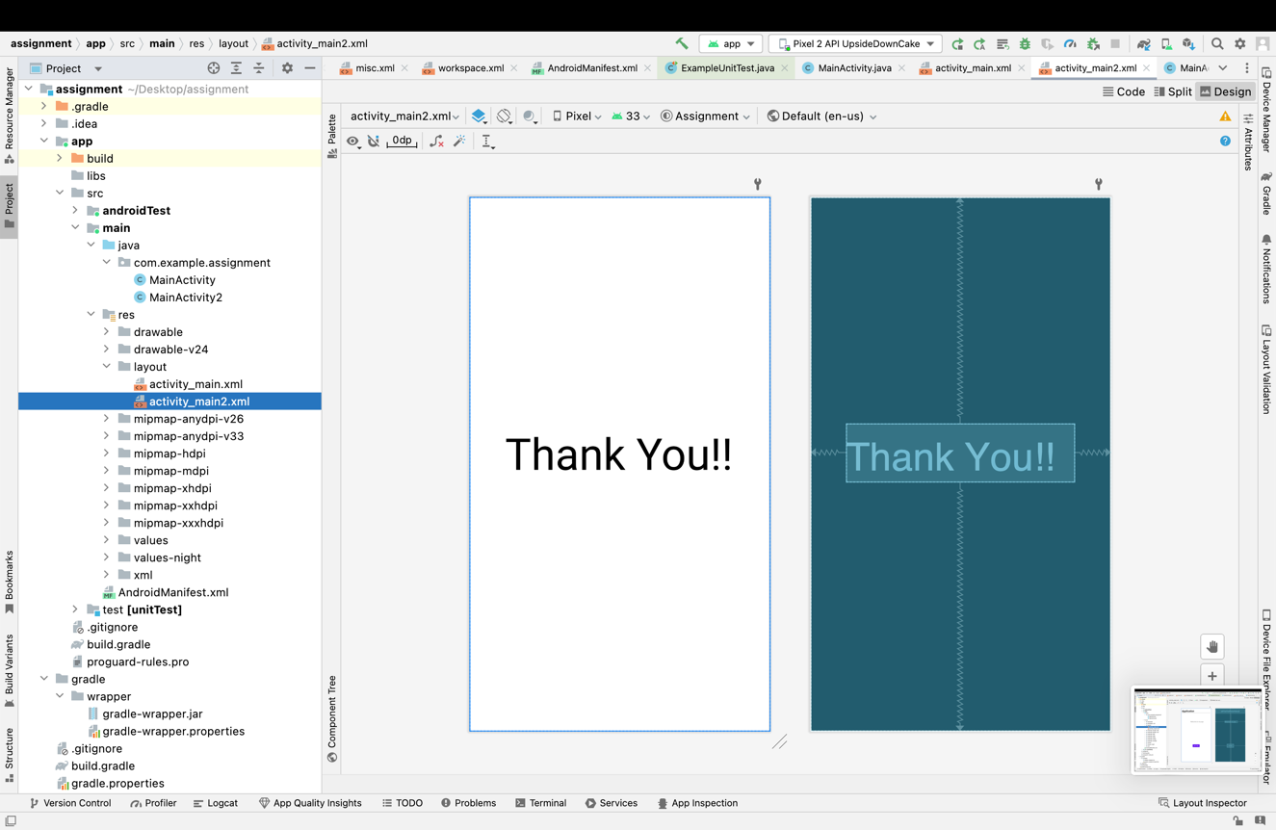

Pic 3: 2nd Activity

Next, I went to AndroidManifest.xml there I changed my Second activity into a default Intent this makes my main activity as a launcher and second activity which is main activity too as a default.

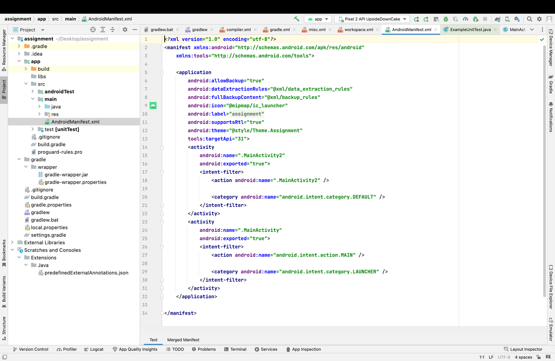

Pic 4: intent change

Later, I went to MainActivity.java there I introduce a private button variable as “Change_text”. Afterward, I created a public class where I linked my button with an Intent to move to my second activity i.e MainActivity2.

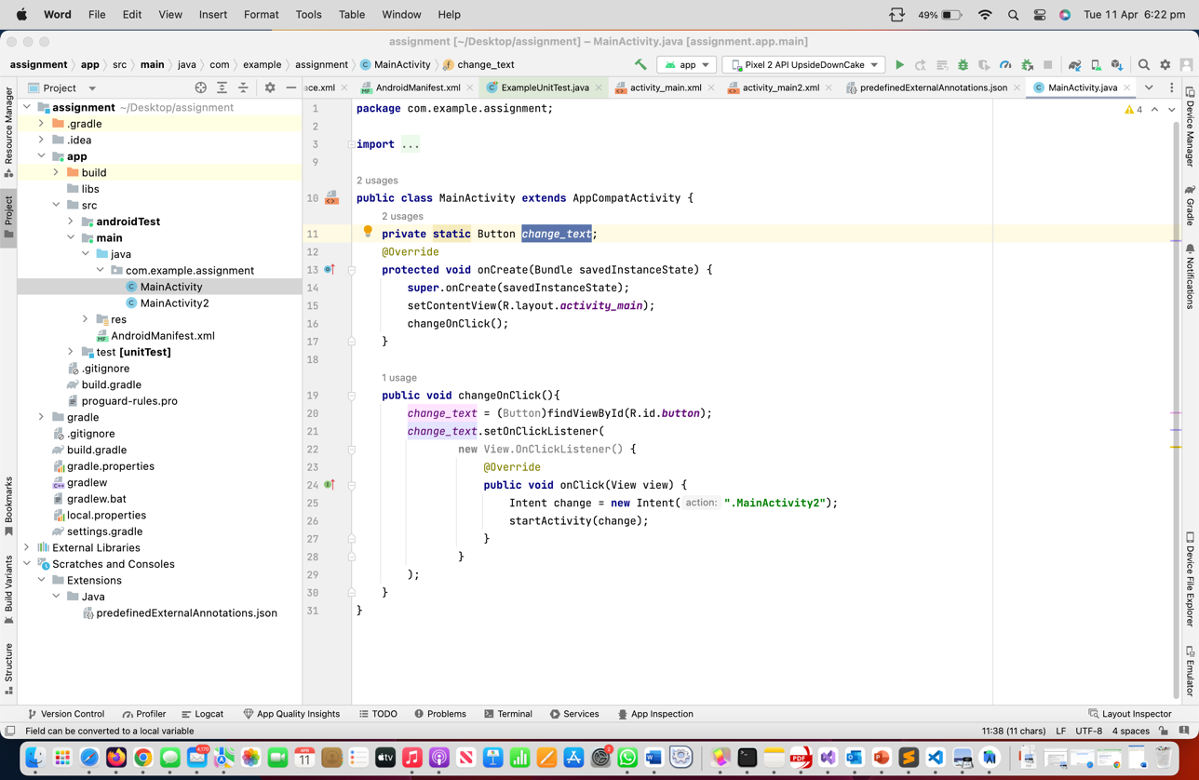

Pic 4: Codes of Main Activity

Then, I ran my project on virtual device. Once the code successfully ran my first activity was shown up. Upon click on the button my second activity opened.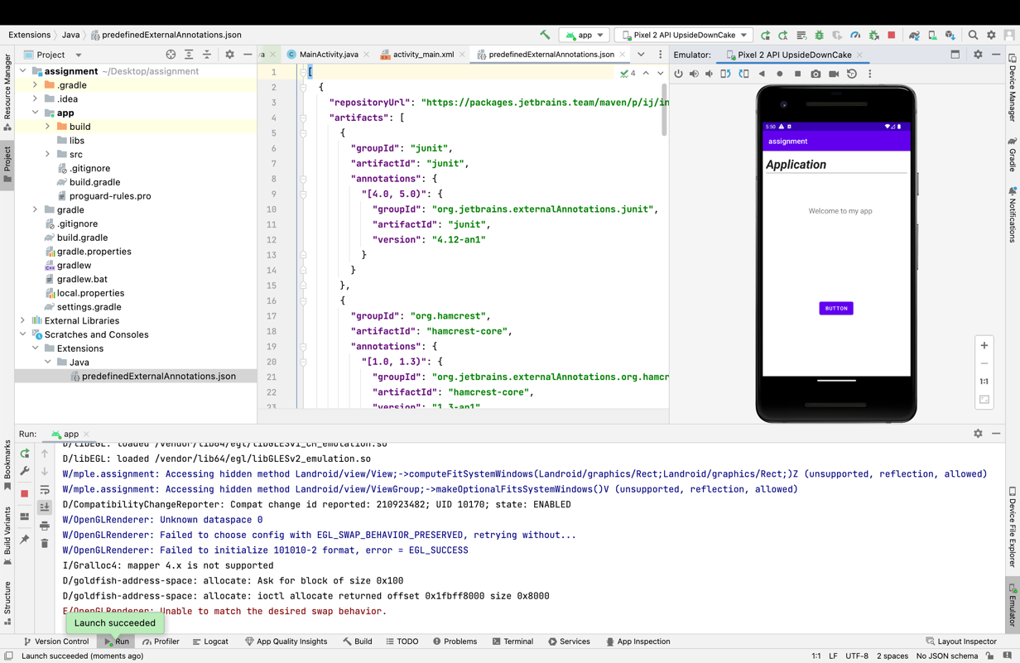

Pic 5: Initial one

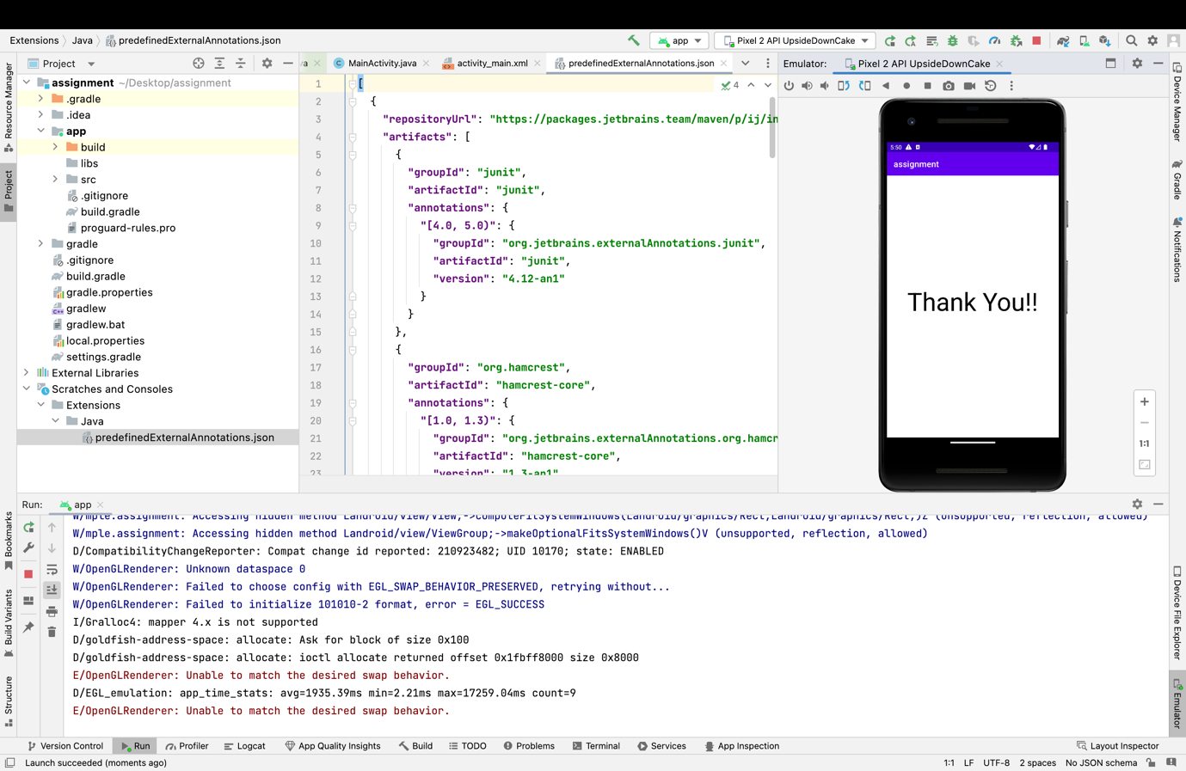

Pic 6: Final one